Project Name | RK-HEALTH
Date | 3 July 2026
Team ID

Phase 1: Empathy Map Canvas

RK-HEALTH Project Empathy Map (User Persona: Rahul, 35, Type-2 Diabetes patient)
SAYS (User Sayings):  • "I need a simple app to track all my doctor visits and medications."  • "I keep forgetting my daily insulin schedule."  • "I want to access my health reports on my phone instantly." | THINKS (User Thoughts):  • "I hope I don't miss my clinic checkup next week."  • "Google searches make me anxious about my symptoms."  • "I wish my care provider could see my compliance log."
DOES (User Actions):  • Sets multiple phone alarms for daily pill reminders.  • Keeps paper doctor prescription slips in folder cabinets.  • Calls clinic desk manually to schedule or change slots. | FEELS (User Emotions):  • Overwhelmed managing multiple medication cycles.  • Frustrated using disjointed notes and tracking tools.  • Hopeful that an integrated portal can simplify his care.
PAINS (User Pain Points):  • Lack of a single app containing lists, calendars, and logs.  • Specialist routing is confusing and hard to choose.  • Poor medication compliance due to manual logs. | GAINS (User Benefits & Goals):  • Peace of mind through Google Calendar integration and alerts.  • Specialized symptom triage and guidance from AI chat.  • Printable report summaries to share with doctors.

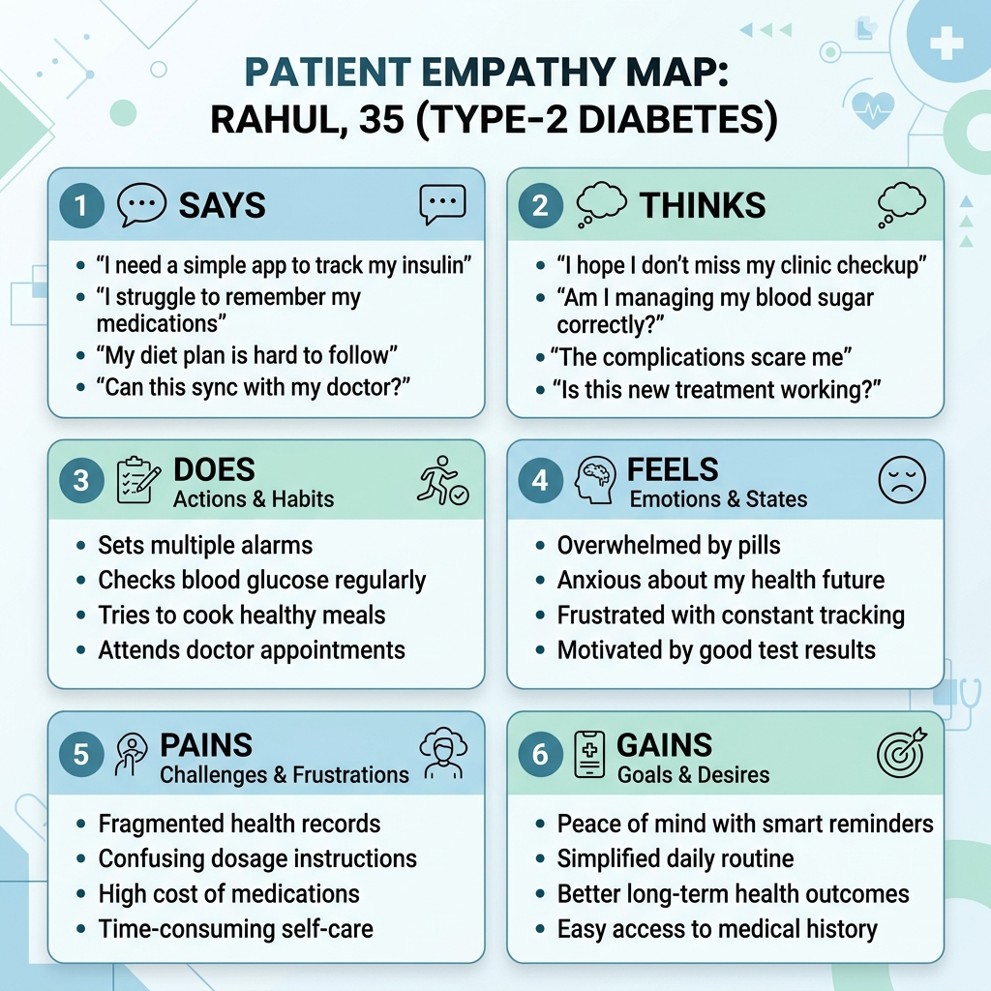
Figure 1: Empathy Map Canvas for Rahul (Type-2 Diabetes Patient Persona)

